## Introduction

The Analog Joystick is a midsized joystick compatible with the XAC or other analog input joystick devices. It has a range of toppers which can simply be press-fit onto the joystick and removed by pulling them off.

## Features

## A photo of the analog connection version of the Oak Compact Joystick, printed in green PLA and brown ABS.A photo of the toppers for the Oak Compact Joystick printed in various colours of PLA.

## Usage

### Using the Joystick

1. Plug the 3.5 mm TRRS cable from the joystick into the host device (such as the Xbox Adaptive Controller). If using the Xbox Adaptive Controller, plug it into X1 to use at the left joystick, or plug into X2 to use as the right joystick.
2. Ensure the arrow on the joystick is pointing in the “up/forward” direction, away from the user.
3. Mount the device if needed (see below).
4. Move joystick as you would with a standard controller.

### Compatibility

This device is compatible with the XAC, [Enabled Controller](https://makersmakingchange.com/project/enabled-controller/), and any other device that accepts a TRRS analog joystick input.

### Changing the Joystick Topper

The toppers are installed and removed simply by pressing the joystick end into the hole in the topper.

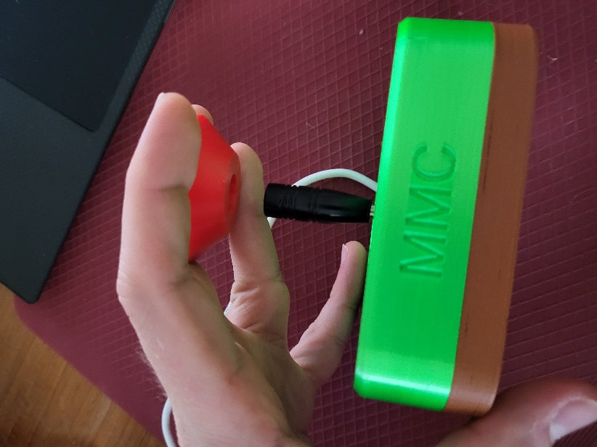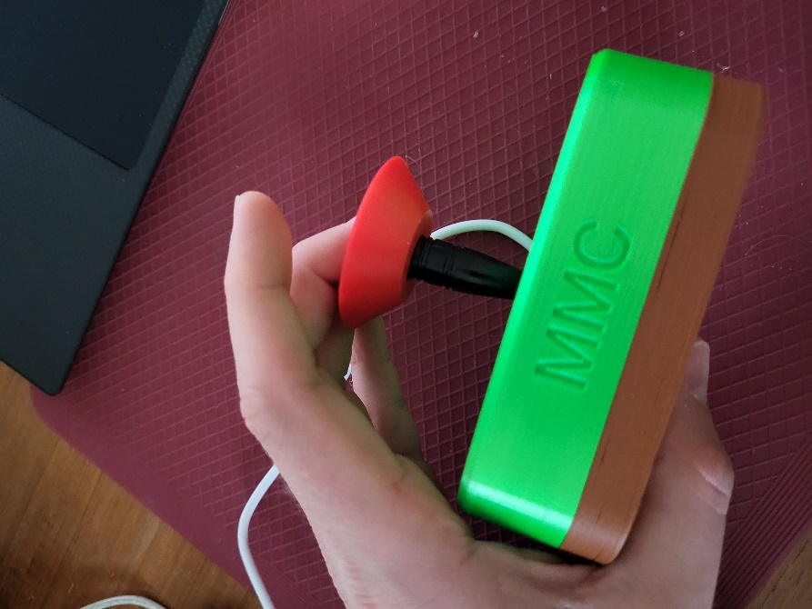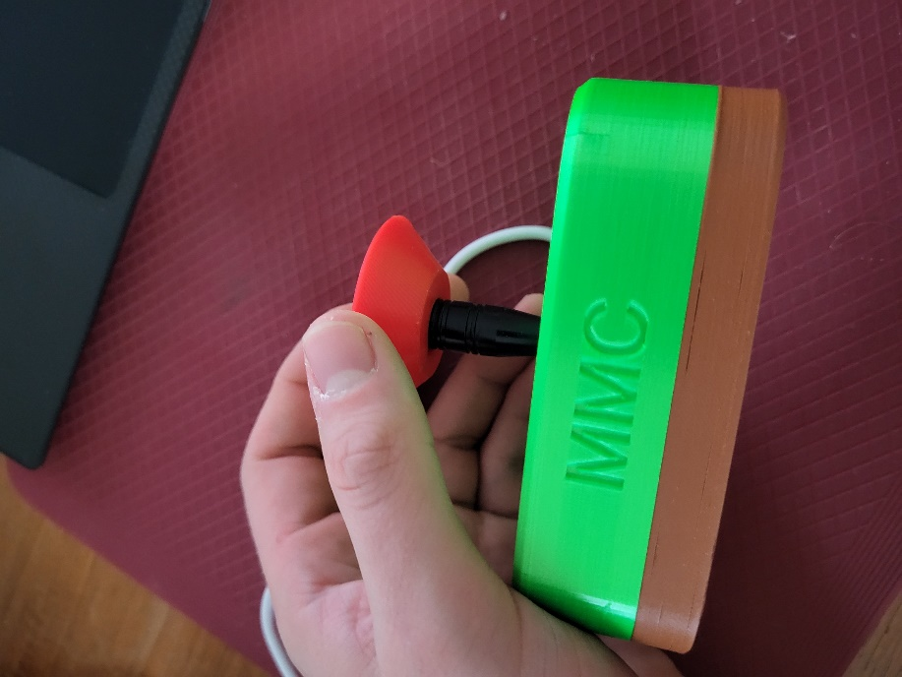

### Mounting the Joystick

The Oak Compact Joystick can be mounted using various methods, depending on your preference and how you can best access it.

**Note**: A different joystick is shown is the following mounting examples, but the same principles and methods will apply to this joystick.

#### Table Top Mounting – Non-Slip Pads

|  |  |
| --- | --- |
| If using the joystick on a tabletop, and height of the joystick is not a concern, nonslip pads can be added in each of the four corners on the bottom, as shown. |  |

#### Table Top Mounting – Hook and Loop Fastener

|  |  |
| --- | --- |
| If using the joystick on a tabletop or other surface with hook and loop fasteners, such as Velcro, stick the hook side (rough side) to the joystick and the loop side (soft side) to the surface to mount to. | Bottom of the joystick with hook and loop fastener attached to the bottom. The hook side is shown stuck to the joystick. |

#### Camera Mount

To mount the joystick on a camera mount, the optional Joystick Camera Mount Adapter can be used by simply screwing it to the bottom with two M3 screws.

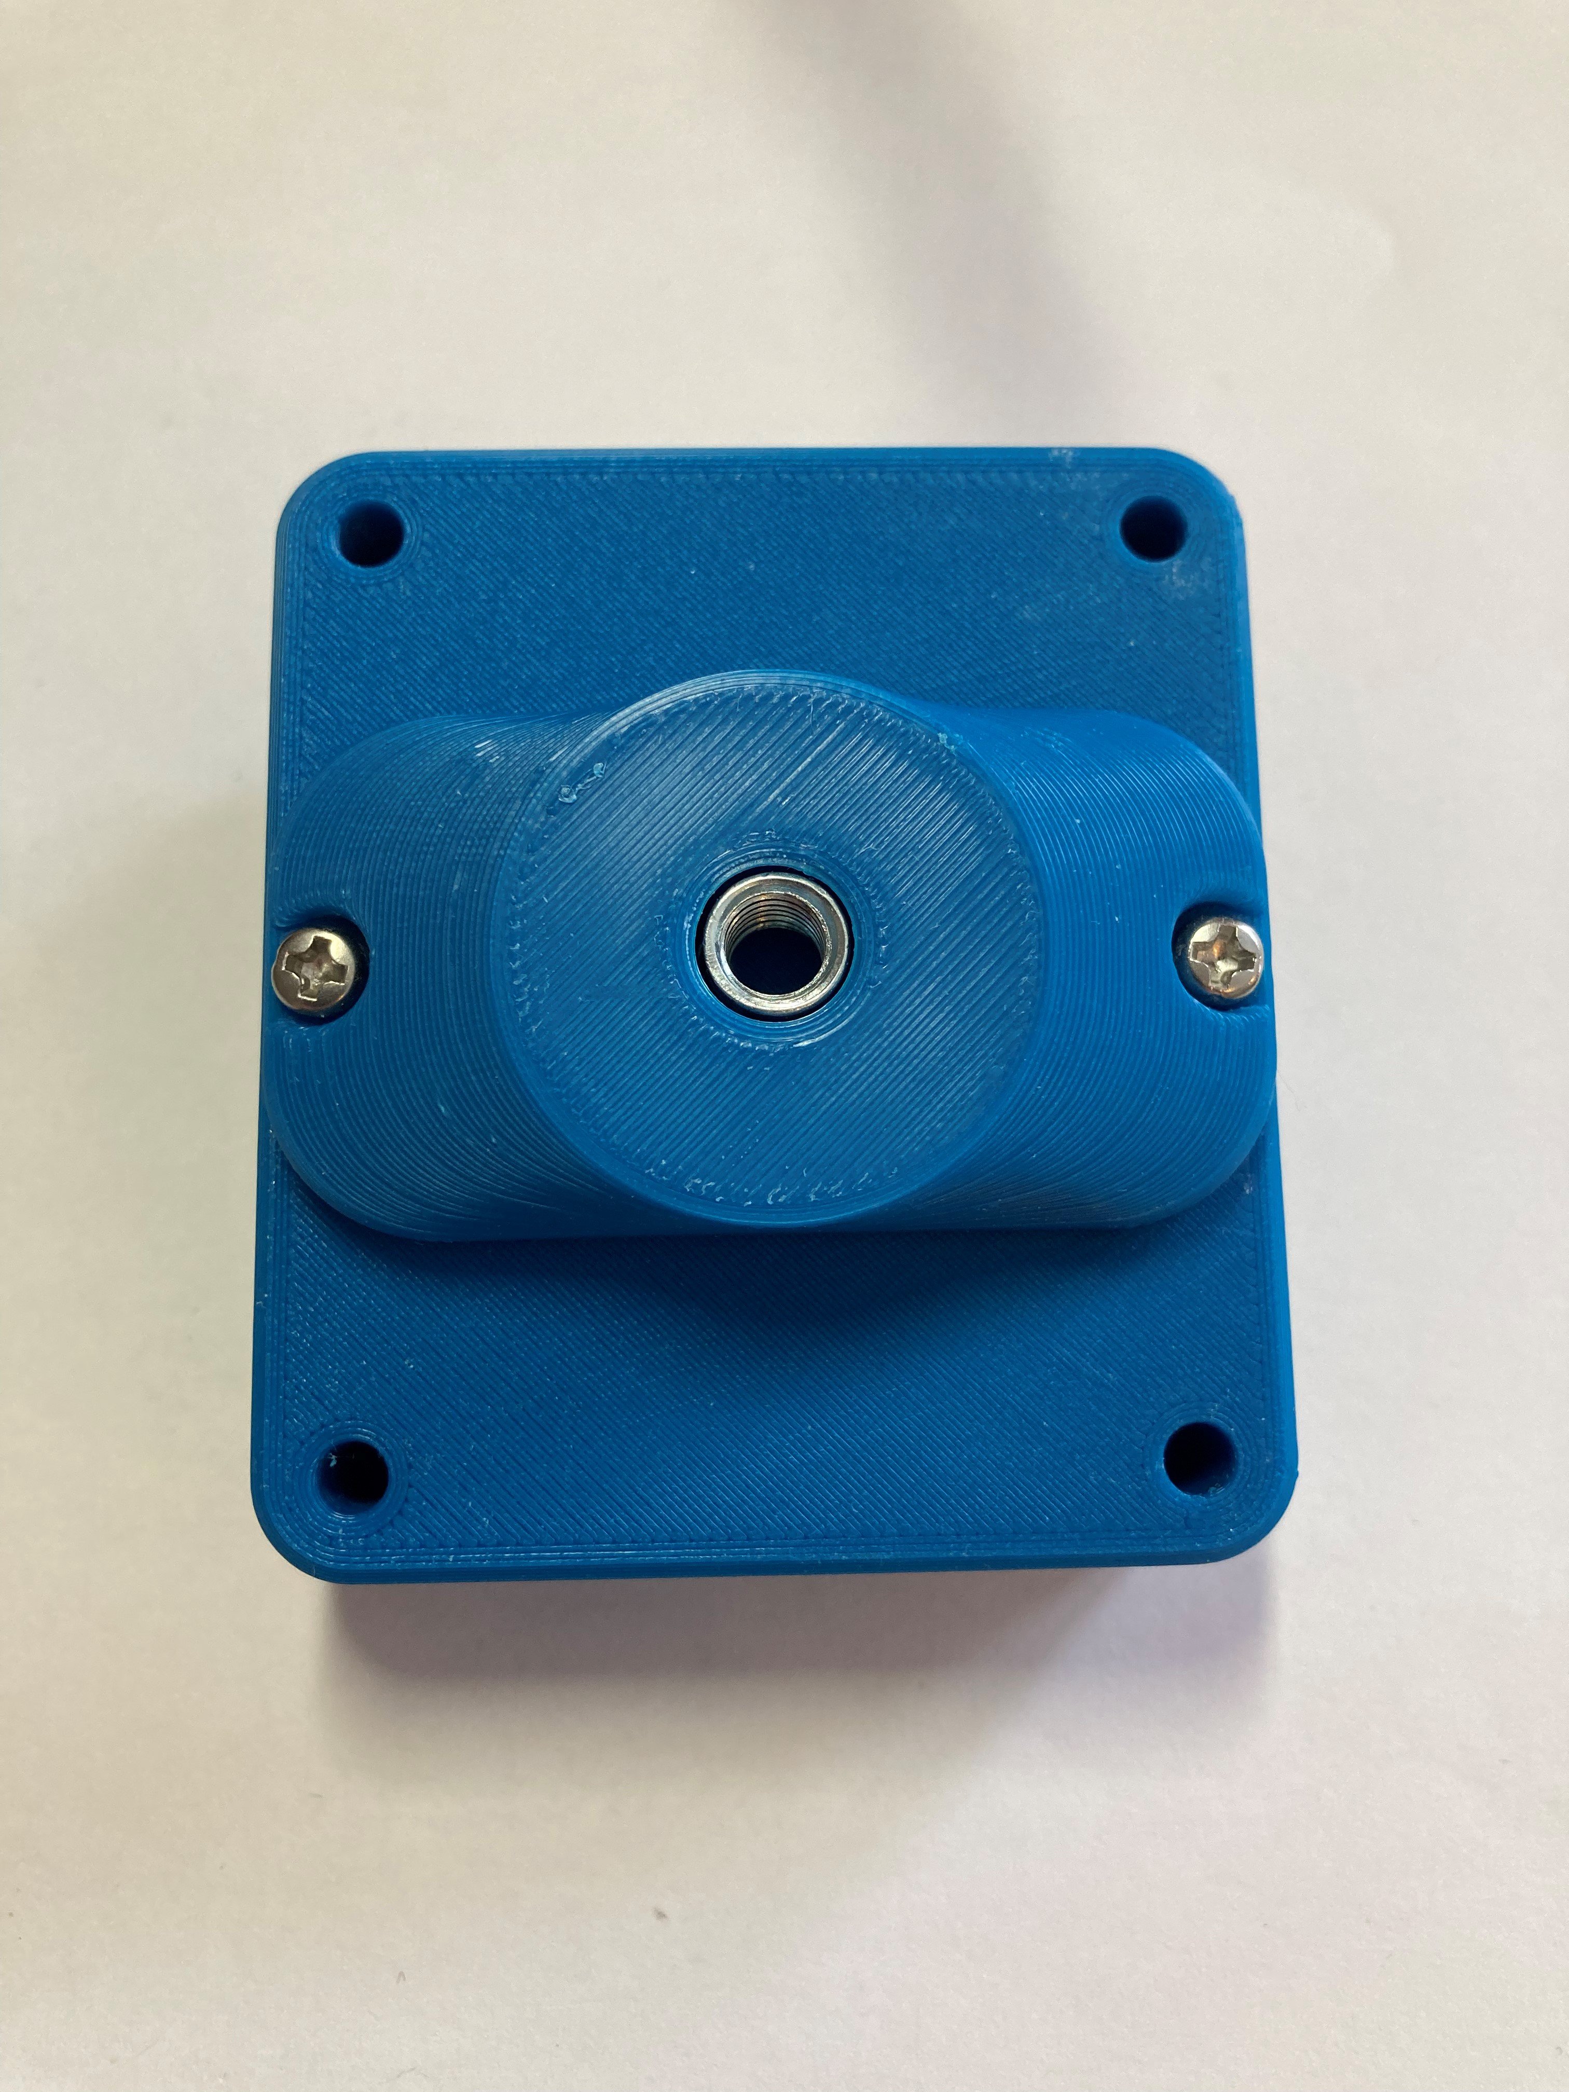

## Specifications

The joystick has a ±25° range of motion and takes approximately 525 grams of force to fully deflect.

|  |  |
| --- | --- |
| Total Height | 65 mm |
| Enclosure Height | 34.4 mm |
| Enclosure Width | 80 mm |
| Enclosure Length | 106 mm |
| Weight | 152 grams |

## Cleaning

Wipe the outside of the device with a lukewarm, damp cloth. Do not use hot water on this device or the plastic housing may warp. Do not submerge the device.